# Database Development

### Introduction

In this lab you will deploy an APEX application to the Alpha Clone PDB and adjust the firewall rules to support access to the application from the Internet using a PC based browser or mobile device.

### Objectives

* Enable APEX in the Alpha Clone PDB.
* Create APEX REST services
* Deploy and access an Alpha Office APEX application.

### Lab Requirements

* The following lab assume that the steps outlined in lab guides 100 and 200 have been completed.
* VNC Viewer for access to the cloud client image
* The SSH tunnels must be active in a terminal window.

### Alpha Office and APEX

#### APEX Workspace Administration

The Alpha Clone database contains an unused APEX configuration. As the first part of this lab we will complete the configuration of the cloned database APEX configuration.

**Note:** The standard install of APEX for a 12c database created many objects shared by both the container and pluggable database but user and password information is always local to the database we access. In other words, the APEX password we set in Lab 100 has not been in the cloned database.

* Make sure the SSH tunnels you set up in lab 100 are still active in your terminal window, if not refer to lab 100 to set up the SSH tunnels.
* During the plug-in operation, many of the common objects in the pluggable database were evaluated by the database and some changes were made to the new database to work with its new container. One of these adjustments was locking the database accounts used to provide REST services. We will need to unlock the APEX_LISTENER and APEX_REST_PUBLIC_USER accounts.
* If it’s not already running, startup SQL Developer from the Cloud Client desktop on the VNC connection.
* Open the DBA Window and locate the Alpha Clone - DBCS item (created in Lab 200) in the **DBA Navigator**
* Expand it and click on the Security🡪Users item.

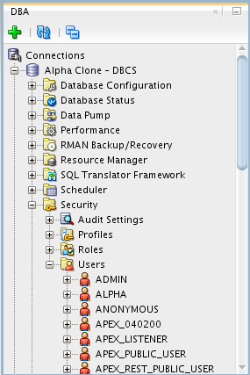

* Right-mouse on APEX_LISTENER and select Unlock User…

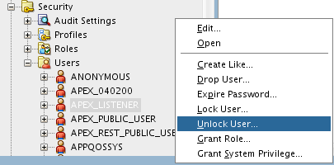

* Click the **Apply** button to unlock APEX_LISTENER. You may also use the SQL tab to review the unlock statement.

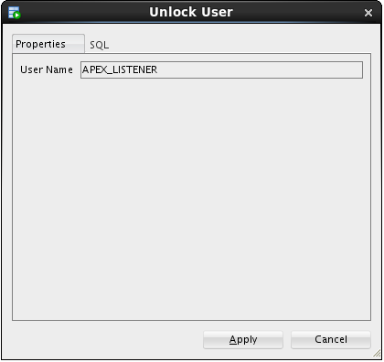 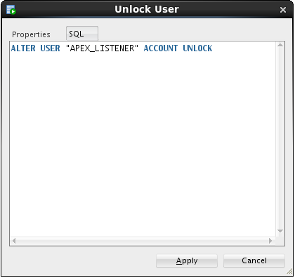

* Repeat the Unlock User… operation for the APEX_REST_PUBLIC_USER.

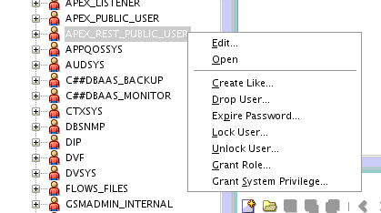

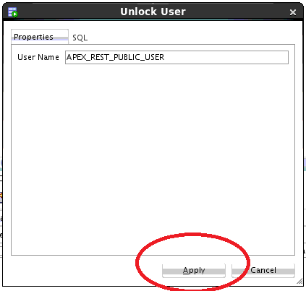

#### Create the Alpha Office workspace

* In the **Chrome** browser, open up a new tab and test the updated rule by accessing the APEX instance in the container database from the Internet. Use the Public IP address from the cloud instance we created in the first lab.

**Note:** Be sure to use the https protocol.

**https://<your-Public-IP>/apex/alphaclone/apex_admin**

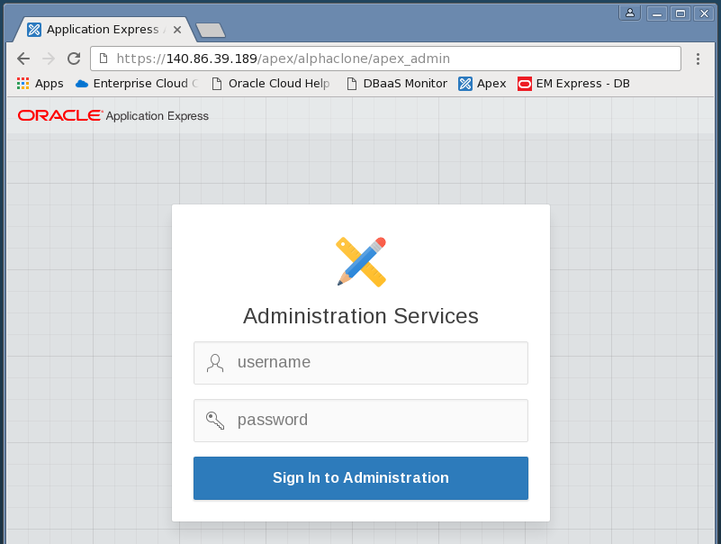

* After you’ve accepted the SSL certificate and see the APEX administration page, enter the following admin credentials and click the Login to Administration button:

|  |  |
| --- | --- |
| **Username:** | admin |
| **Password:** | Alpha2014_ |

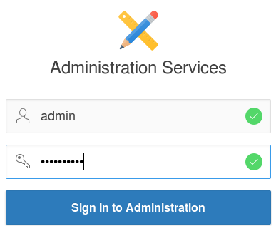

* You **may** be prompted to change the ADMIN user password, if not, skip to the next step. These credentials apply to the APEX objects local to the pluggable database. For convenience, we will enter the same password as the container database.
* Enter the following values and click the **Apply Changes** button.

|  |  |
| --- | --- |
| **Enter Current Password:** | Alpha2014_ |
| **Enter New Password:** | Alpha2015! |
| **Confirm New Password:** | Alpha2015! |

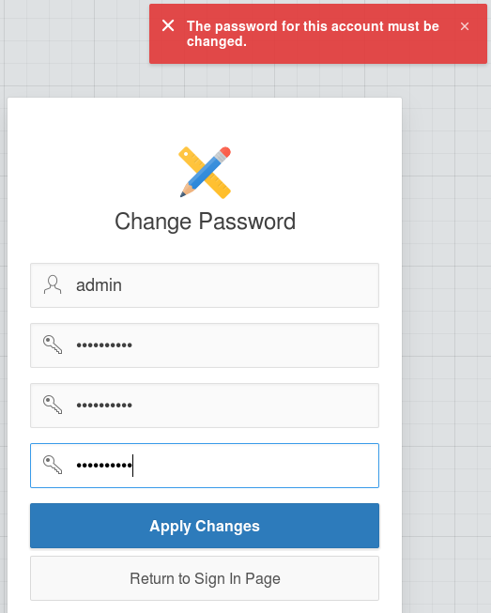

* After logging in successfully, feel free to click around in the APEX interface to get familiar with it.
* When you’re ready to begin, click the Create Workspace button

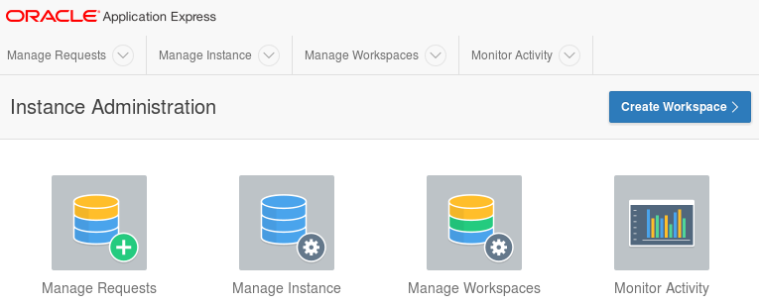

* At the Identify Workspace dialog, enter the following workspace name and click the Next button.

|  |  |
| --- | --- |
| **Workspace Name:** | AlphaDev |

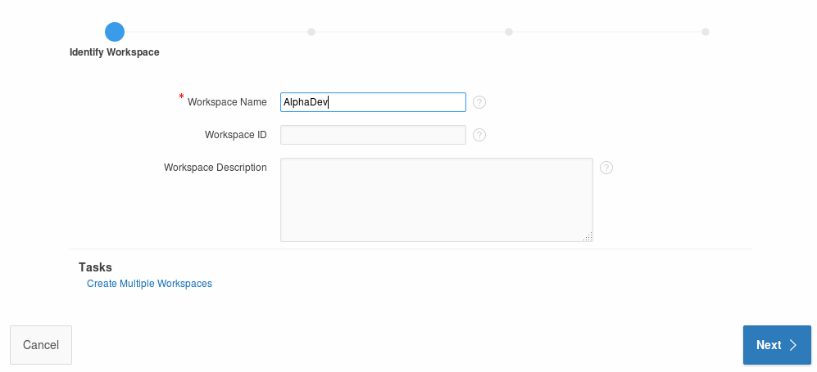

* At the Identify Schema dialog, select and enter the following values followed by the Next button.  
    
  **Note:** Use the search icon  to find the ALPHA schema.

|  |  |
| --- | --- |
| **Re-use existing schema?** | Yes |
| **Schema Name:** | ALPHA |

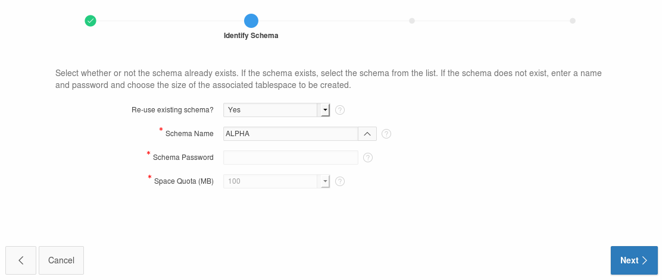

At the Identify Administrator dialog, enter the following values and click the Next button.

|  |  |
| --- | --- |
| **Administrator Username:** | ADMIN |
| **Administrator Password:** | Alpha2014_ (May be prompted to change) |
| **Email:** | dummy@localhost.localdomain |

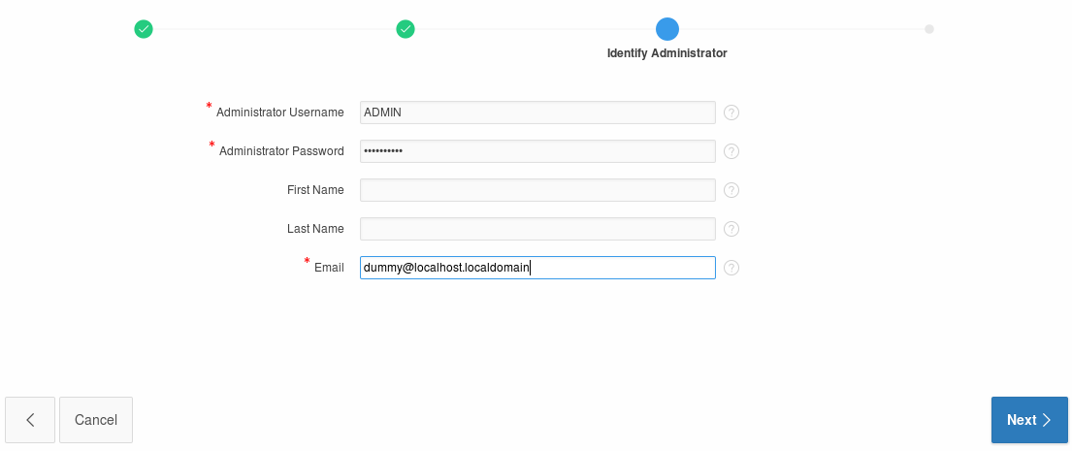

* Review the selections on the Confirm Request page and then click the Create Workspace button.

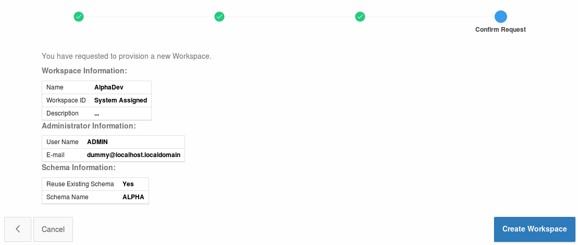 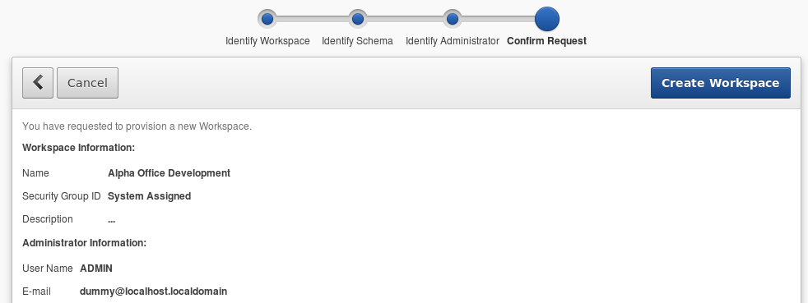

* APEX will display the ‘Workspace Created’ message
* Click Done



* Click the ADMIN dropdown in the upper right and select Signout

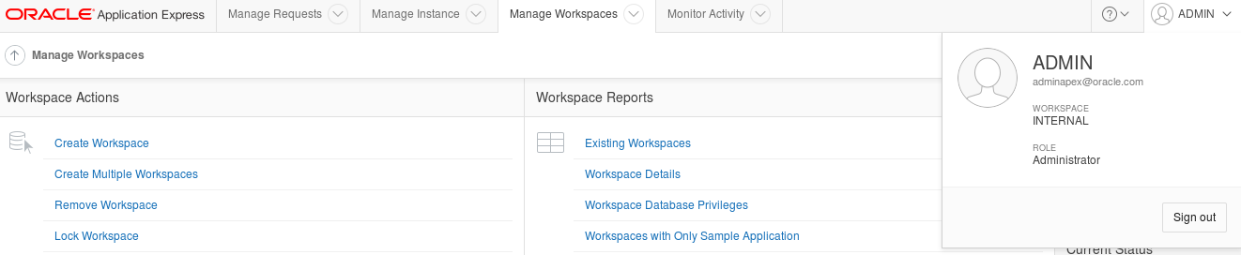

* Click the Return to **‘Sign In Page’** to continue



#### Build REST services

* Login to the Alpha Office APEX development workspace using the following credentials.

|  |  |
| --- | --- |
| **Workspace:** | AlphaDev |
| **Username:** | ADMIN |
| **Password:** | Alpha2014_ |

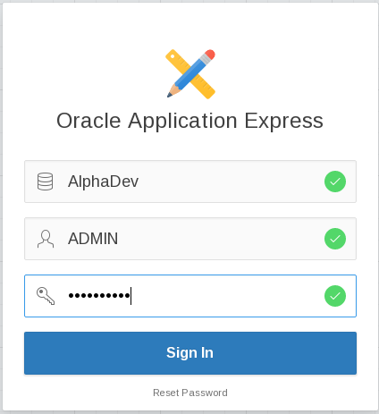

* You **may** be prompted to change your password. Enter the following values and click the Apply Changes button.

|  |  |
| --- | --- |
| **Enter Current Password** | Alpha2014_ |
| **Enter New Password** | Alpah2015! |
| **Confirm New Password** | Alpha2015! |



* Once you’ve logged in successfully, click the SQL Workshop button.

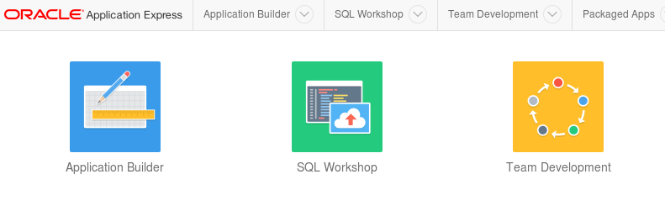

* Click the RESTful Services button.

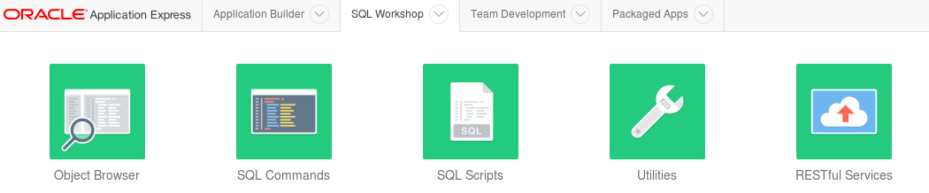

* Click the Create > button

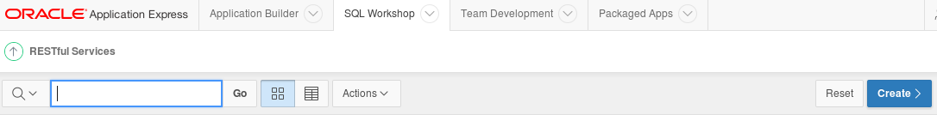

* There are three sections on the RESTful Services page:
* Restful Services Module
* Resource Template
* Resource Handler

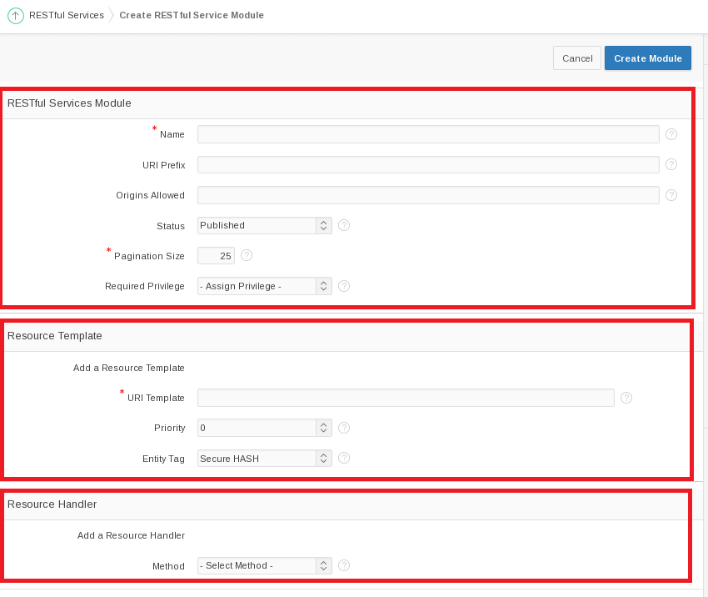

* Fill out the information for these sections using the information provided below.
* For the **RESTful Services Module** section, use the following values:

|  |  |
| --- | --- |
| **Name:** | alpha.office |
| **URI Prefix:** | alphaofc/ |

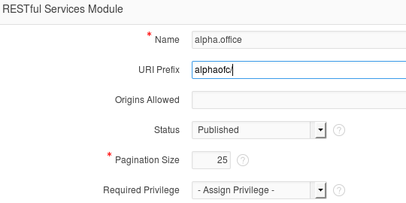

* In the **Resource Template** section enter the following value:

|  |  |
| --- | --- |
| **URI Template** | products/ |

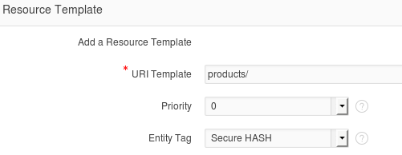

* For the last section titled **Resource Handler** use the following values:

|  |  |
| --- | --- |
| **Method:** | GET |
| **Source Type:** | Query |
| **Format:** | JSON |
| **Source:** | select * from products |

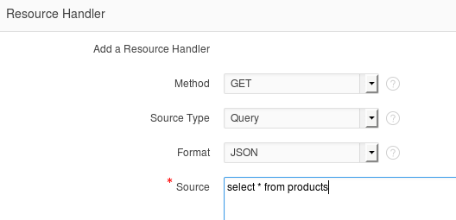

* Click Create Module to complete the REST service creation.



* APEX will show the new service module with a confirmation message.
* Click the GET handler for our template in the folder structure on the left of the screen.

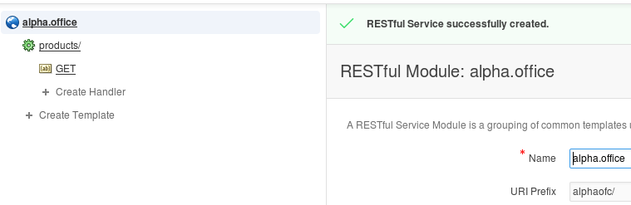

* Review the definition.
* Since this operation has no parameters, we can easily test it by clicking the Test button.

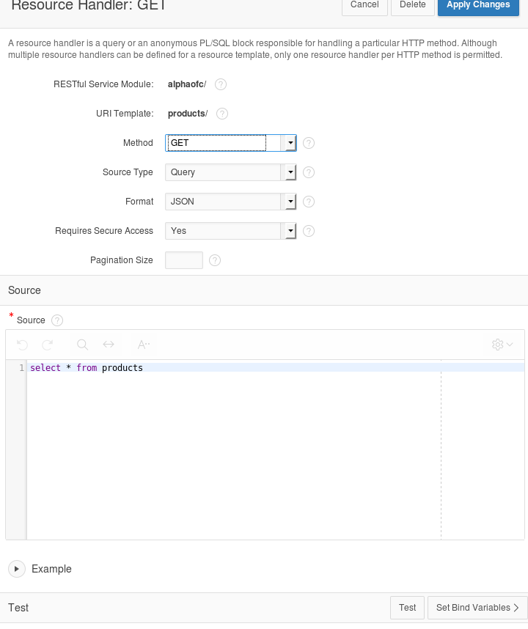

* Review the JSON produced by the service.
* Click the browser's back button to return to the APEX page.

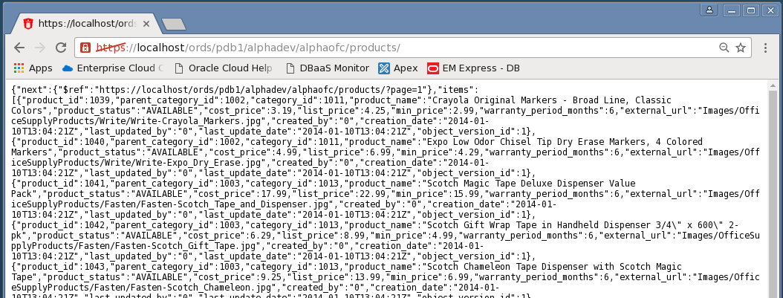

#### Create a Parameterized REST Service

* In the next section we will create a REST service that takes a product number and returns only one database row as a JSON object.
* Click the Create Template link.

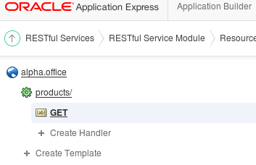

* Enter the following URI Template.

**Note:** The {id} syntax indicates the REST call accepts one parameter named "id" - this is automatically available in later for SQL queries.

* When the entry is complete, click the Create button.

|  |  |
| --- | --- |
| **URI Template:** | product/{id} |

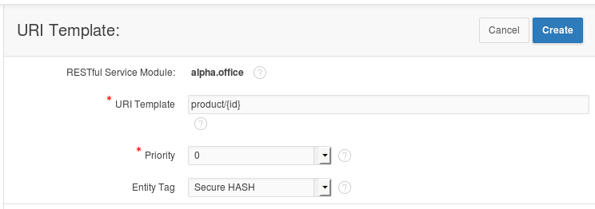

* APEX displays a success message for the new template
* Click the Create Handler link under the product/{id} template on the left side of the screen.

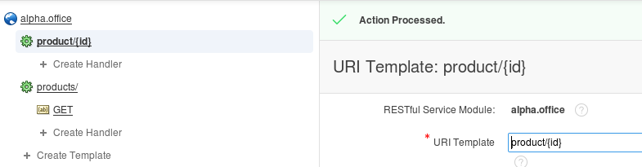

* Enter the following SQL statement in the Source field of the Resource Handler page. Notice the use of the ":id" bind variable, this value comes from the URI template {id} provided when the service is invoked.

**Source:**

select *

from products

where product_id = :id

* Once you’ve finished entering the SQL statement, click the Create button.

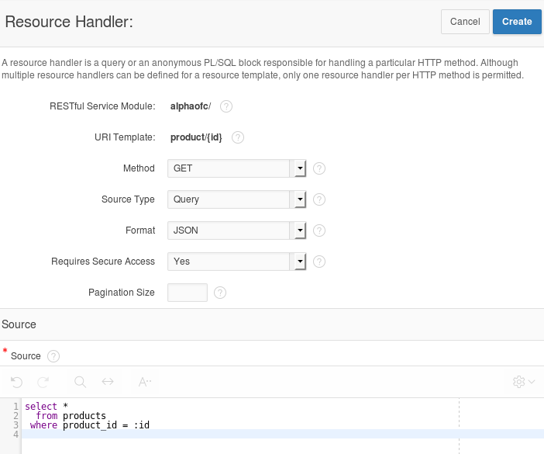

* Notice the ‘Action Processed’ at the top of your screen. We will test this service just like before, but we need to provide a product number to the call.
* Scroll to the bottom of the page and in the Test section, click the Set Bind Variables button.

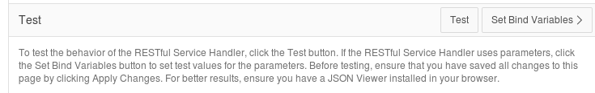

* Enter the following product number and click the **Test** button.

|  |  |
| --- | --- |
| **:ID** | 1020 |

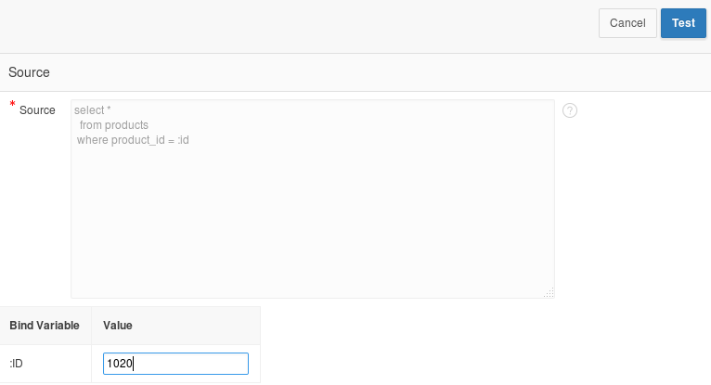

* In the new browser window, notice only the single product shows in the JSON object.
* Close this pop-up window.

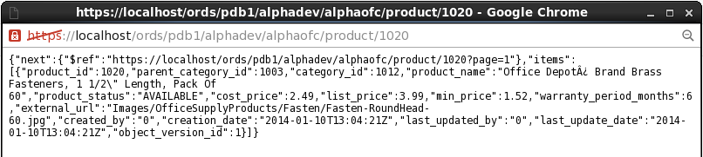

#### Install APEX Mobile Application

* Click the Application Builder menu item on the APEX page.

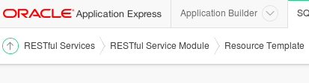

* Click the Import button on the Application Builder page.

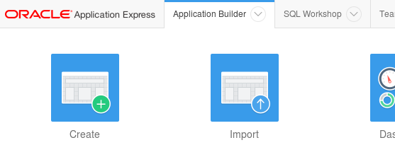

* Click the Browse button to locate the APEX application export file.

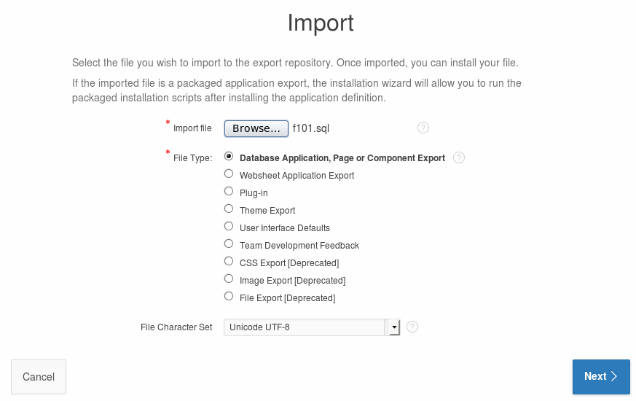

* Locate and open the following file and click the Open button:

**/u01/OPCWorkshop/lab/f101.sql**

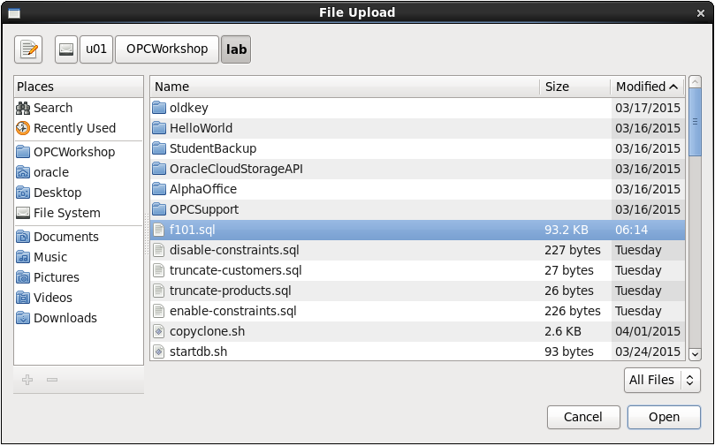

* Click the Next button to continue.



* After a brief pause while the application file is processed, click the Next button to continue.

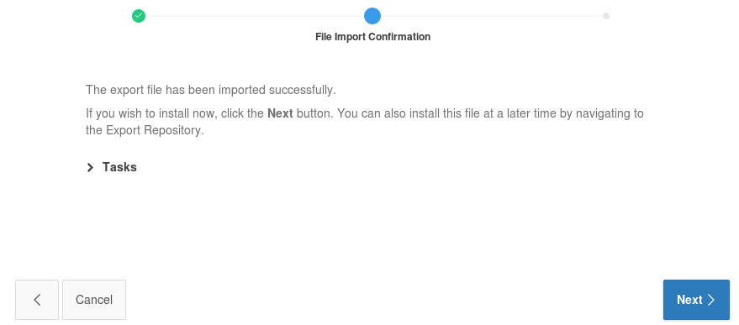

* On the final page, select to Reuse Application ID 101 from Export File
* Click Install Application. 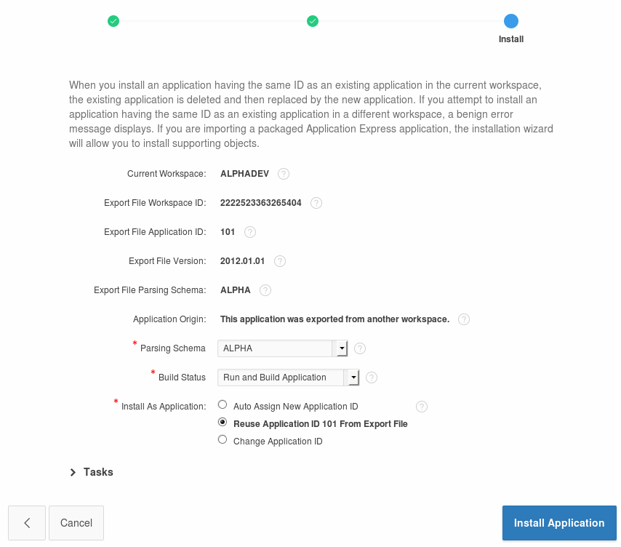
* APEX displays a success message for the import
* Click **Run** Application.

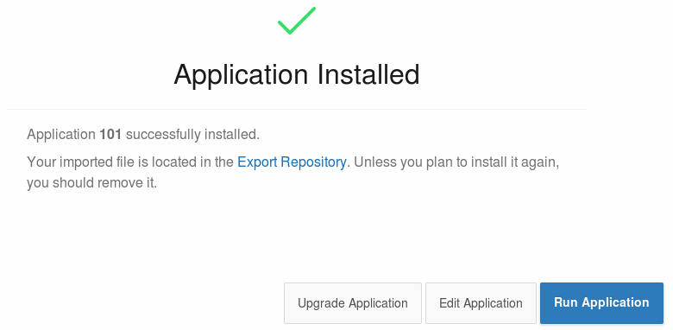

* APEX renders the first page of the mobile application in the browser – it might not look quite right since we are using a mobile template.

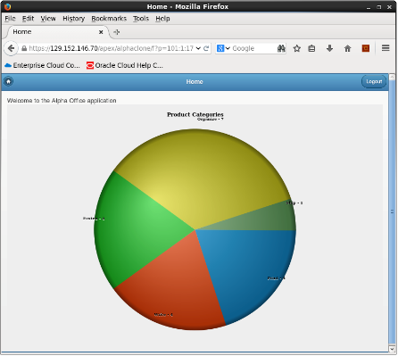

#### Access the Alpha Office Mobile Application on your Smart Device

* Using any Internet connected smart phone or tablet we will access the mobile application using the port we opened earlier in the lab. This example is using an Apple iPhone 5s.
* Use your device's browser and navigate to the following URL:

**https://< Public IP Address of Alpha01A-DBCS>/apex/alphaclone/f?p=101**

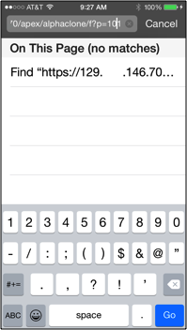

***Note:*** *It may be more convenient to email the link to your device.*

* The browser should prompt you to accept the unknown certificate.
* Click of touch Continue.

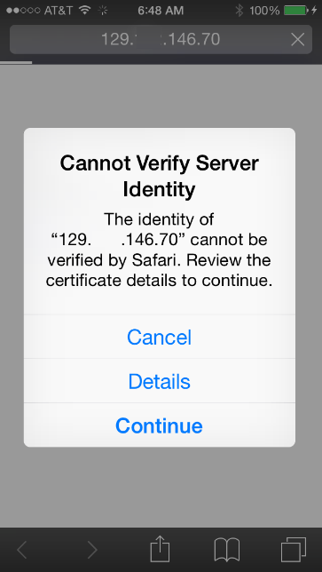

* Touch the screen to explore the application. On the device, touching one of the pie slices highlights the slice; a second tap drills into that slice.

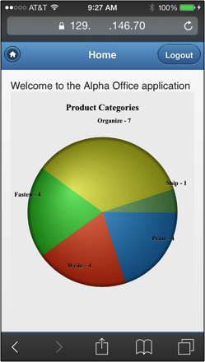

* Congratulations, you’ve created an application on the Oracle Database Cloud. This is the final lab for the DBCS Workshop.